This half term our topic is ‘Space & Aliens’.

Throughout this topic we will be reading the children’s book ‘Alien’s Love Underpants’. We will be looking at fantasy stories, children’s book preferences and the vocabulary used – including rhyme.
We will be designing a space rocket, looking at the different material used for purpose in science and even trying to a real life astronaut through Tim Peak’s twitter!

The children will also be sorting aliens into graphs and pictograms, trying to understand what it would be like to be an alien on a different planet and not the same as everyone else.

Spellings and IXL maths will continue to be sent out weekly and the additional project homework will be to design and draw and alien spacecraft – labelling the different materials used and why! It would be beneficial if parents would support their children in producing a project. All children who bring in a project will be rewarded and will get to share their project with their peers.

In addition we ask that as ongoing support for your child that number bonds to 10/20 and times tables 2, 5 & 10 are practiced at home as the children need this knowledge at their fingertips every day!
Reading to and with your child is also very important and we ask that even if when it’s during cooking tea children can read out loud to somebody at home regularly.

Useful Websites

There are many age appropriate websites to be found.
We have found the following to be a good source of information:

Aliens In Underpants Save The World | Teaching Ideas
www.teachingideas.co.uk/library/.../aliens-in-underpants-save-the-world

Aliens Love Underpants! - Teaching Ideas and Resources
www.teachingideas.co.uk › Claire Freedman

Aliens Love Underpants on Pinterest | Aliens, Space Theme ...
https://uk.pinterest.com/tnlanning/aliens-love-underpants

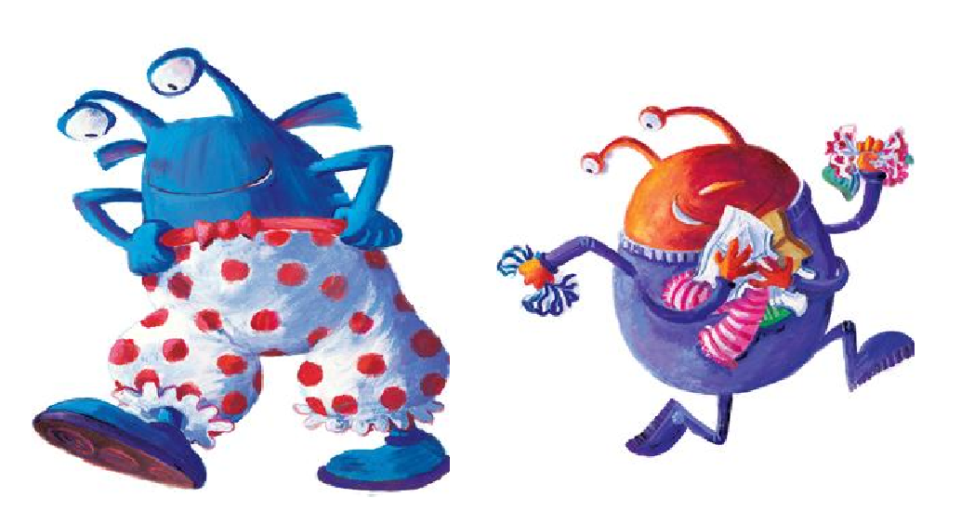

Space & Aliens

