Please send completed projects into school by Monday 16th July 2018. Presentations can be emailed, if desired, to: admin@hollingworth.tameside.sch.uk
Please make it clear in the subject line whose work it is and which teacher the email is for the attention of.

Many thanks for your continued support.

Homework Project
Year 3 and Year 4

Hollingworth

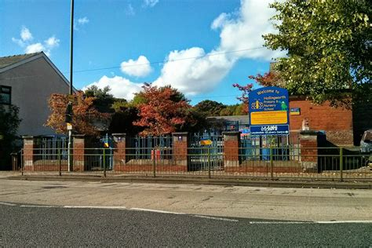
This half term our topic is based on Hollingworth.
During the half term, the children will be learning about Hollingworth’s different geographical features including: landmarks, land use and famous local eg. LS Lowry, Vivienne Westwood, Bill Sowerbutts.
Alongside reading and online spelling and numeracy homework, it would be beneficial if parents could support children by contributing to our topic. A trip to the library for books and shared reading would be a good start. The following websites are also good sources of information.
https://www.tameside.gov.uk/longdendale/history
https://www.britishlistedbuildings.co.uk/101449368-hollingworth-war-memorial-longdendale-ward
https://www.thelowry.com/events/ls-lowry
http://primaryfacts.com/2248/l-s-lowry-facts-and-information/
We would like the children to research a specific local theme eg. sport, culture, clubs, famous locals to share with the class; this should reflect their skills.

The project outcome can be as creative as you like and could include:

- A presentation
- A picture eg. sketching or painting of a famous landmark,
- A piece of writing eg. retelling a story in the manner of a local tale, in the surrounding countryside.
- This could include constructing a model of a local landmark.

