Useful websites:
https://en.wikipedia.org/wiki/The_Lion,_the_Witch_and_the_Wardrobe
https://www.sparknotes.com/lit/lion/
https://www.sparknotes.com/lit/lion/characters/
https://www.ehow.com/info_8568330_crafts-lion-witch-wardrobe.html
https://ourpastimes.com/crafts-on-the-lion-the-witch-the-wardrobe-for-kids-12595323.html
https://www.activityvillage.co.uk/narnia

Autumn Term 2, 2018
Year 3 and Year 4

Narnia
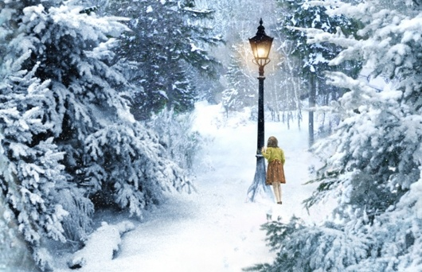

This half term our topic is:
Narnia
Our class text is:
The Lion,The Witch and The Wardrobe
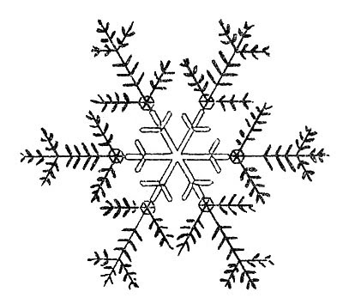

We would like you to draw, paint or make a model of a scene from The Lion, The Witch and The Wardrobe using art materials, modelling materials, a computer, electrical circuits or anything else that you think is appropriate. Be as creative as you want!

Completed projects should be sent into school by Monday 17th December so that children have a chance to share them with the class.

Digital projects can be emailed, if desired, to admin@hollingworth.tameside.sch.uk
Please make it clear in the subject line whose work it is and which teacher the email is for the attention of.

