This half term our topic is ’Journeys’.

Throughout this topic we will be reading through the amazing book ‘The Snail and the Whale’ by Julia Donaldson. We will be describing the characters using synonyms, adjectives and adverbs. In addition to creative writing we will be using Atlases to look at where different continents and countries are as well as landscapes and geographical features.

Alongside literacy and numeracy homework, it would be beneficial if parents would support their children in producing a project.

All children who bring in a project will be rewarded and will get to share their project with their peers as well as the other classes in school.

Please send completed projects into school by the last week of half term . Presentations can be emailed, if desired, to admin@hollingworth.tameside.sch.uk Please make clear in the subject line whose work it is and which teacher the email is for the attention of.

Project Ideas
We would like the children to produce something about the Antarctic.
The project outcome can be as creative as you like. We have previously had children:
- design posters
- make PowerPoint presentations
- create story boards
- pictures – piece of art work
- mini booklet of information
- write a report.

Useful Websites

There are many age appropriate websites to be found.
We have found the following to be a good source of information:

https://www.bing.com/videos/search?q=snail+and+the+whale&qpvt=snail+and+the+whale&FORM=VDRE

www.teachingideas.co.uk/library/books/the-snail-and-the-whale

https://uk.pinterest.com/wilsonrachel110/the-snail-and-the-wha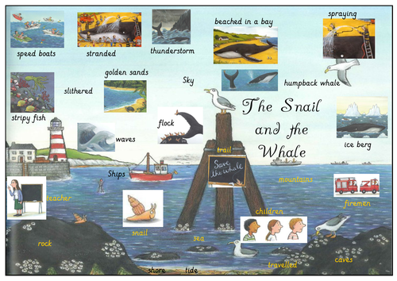
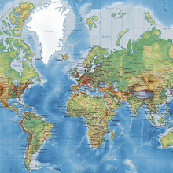

Journeys

