This half term our topic is ’Pirates’.
Throughout this topic we will be reading the well known story – ‘The Pirate Cruncher.’
We will be looking at famous pirates and stories about their adventures. The children will describe the different characters in the book in details, as well as the setting from the book. We will describe our own pirates and think about what adventures they would have in the form of a narrative.
We will be looking at diet and health in our science lessons – concentrating on how our body works and what makes us healthy.

The children will be designing and making treasure maps – looking at co-ordinates and map symbols.

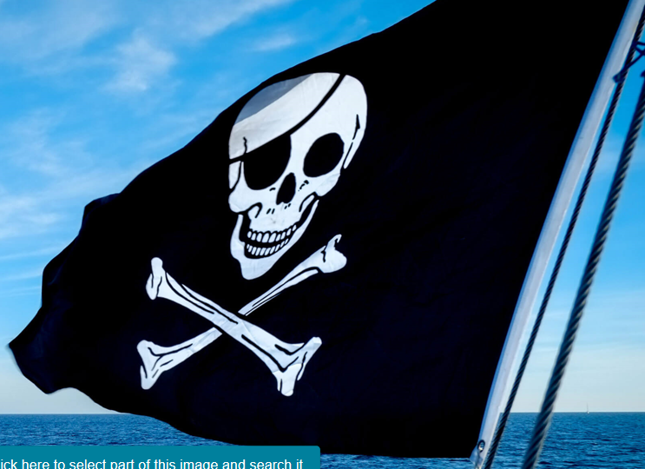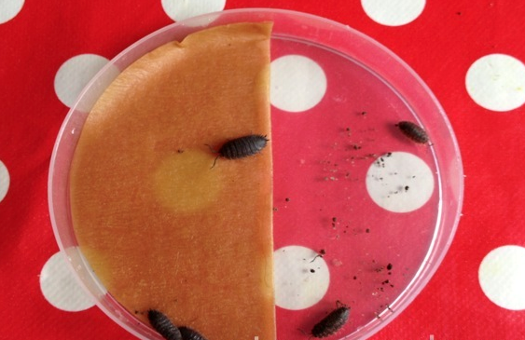

Vocabulary & definitions

Literacy
clambered – climbed over
fiddler – someone who plays a fiddle
cowardly – lacking courage
doubloons- money used by pirates
plunder – seize by force
unfurled – unfold
shanty – song sung by pirates

Science
hygiene - cleanliness
exercise - activity
senses – hearing etc
offspring - baby
observation - notice
heart rate – heart beat

Geog / Hist
co-ordinates – points on a map
significant – importanty
chronology – order of time
contrasting – different
symbols – pictures

All children who bring in a project will be rewarded and will get to share their project with their peers.
Please send completed projects to school during the last week.

Project.
We would like the children to try produce a treasure map!

The children can do it on the computer, create instructions on how to make a map or a report on what they are used for.

Useful Websites
There are many age appropriate websites to be found.
We have found the following to be a good source of information:

https://www.teachingideas.co.uk/library/books/the-pirate-cruncher

https://www.youtube.com/watch?v=QLBAcBcE0_k

Pirates
