This half term our topic is ‘Oceans’.

Throughout this topic we will be reading the children’s book ‘Rainbow Fish to the Rescue’. We will be looking at friendship stories, children’s book preferences and the vocabulary used.

The children will also be describing the characters in the book, looking at what friendship means, designing fish scales and using dying techniques to create watery textiles.

Spellings and IXL maths will continue to be sent out weekly and the additional project homework can include anything to do with our oceans topic – a piece of writing, picture, model or even powerpoint!
It would be beneficial if parents would support their children in producing a project. All children who bring in a project will be rewarded and will get to share their project with their peers.

In addition we ask that as ongoing support for your child that number bonds to 10/20 and times tables 2, 5 & 10 are practiced at home as the children need this knowledge at their fingertips every day!
Reading to and with your child is also very important and we ask that even if when it’s during cooking tea children can read out loud to somebody at home regularly. Please make sure that children have their diaries signed at least 3 times every week!

Useful Websites

There are many age appropriate websites to be found.
We have found the following to be a good source of information:

http://www.teachingideas.co.uk/library/books/the-rainbow-fish

Vocabulary

Literacy
Shimmering exhausted rainbow proud
friendship reluctant hesitate sparkling

Topic
ocean continent direction Earth water
seas country map planet

Science

habitat mammal reptile insect fish
food chain identify dead/living

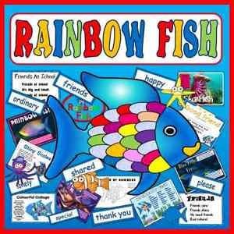

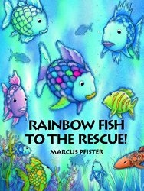
OCEANS – Rainbow Fish

